MODERN PORTFOLIO THEORY AND INVESTMENT ANALYSIS
9TH EDITION

ELTON, GRUBER, BROWN, & GOETZMANN

The following exam questions are organized according to the text's sections. Within each section, questions follow the order of the text's chapters and are organized as multiple choice, true-false with discussion, problems, and essays. The correct answers and the corresponding chapter(s) are indicated below each question.

PART 2: PORTFOLIO ANALYSIS

PART 2 – Section 1: Mean Variance Portfolio Theory

Multiple Choice

1. The risk on a portfolio of assets:
a. is different from the risk on the market portfolio.
b. is not influenced by the risk of individual assets.
c. is different from the risk of individual assets.
d. is negatively correlated to the risk of individual assets.
Answer: C
Chapter: 4

2. Which of the following is correct of how the returns on assets move together?
a. Positive and negative deviations between assets at similar times give a negative covariance.
b. Positive and negative deviations between assets at dissimilar times give a negative covariance.
c. Positive and negative deviations between assets give a zero covariance.
d. Positive and negative deviations between assets at dissimilar times give a positive covariance.
Answer: B
Chapter: 4

3. An efficient frontier is:
a. a combination of securities that have the highest expected return for each level of risk.
b. the combination of two securities or portfolios represented as a convex function.
c. a combination of securities that lie below the minimum variance portfolio and the maximum return portfolio.
d. a combination of securities that have an average expected return for each level of risk.
Answer: A
Chapter: 5

4. Two companies Amber and Bolt are manufacturers of glass. The securities of the companies are listed and traded in the New York Stock Exchange. An investor’s portfolio consists of these two securities in the proportion of 5/6 and 1/6 respectively. Amber’s security has an expected return of 20% and a standard deviation of 8%. Bolt has an expected return of 15% and a standard deviation of 5%. The correlation coefficient between the two securities is 0.6. Calculate the expected return and the standard deviation of the investor’s portfolio.
a. 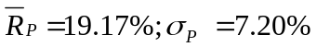
b. 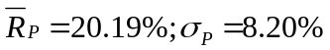
c. 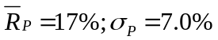
d. 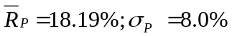
Answer: A
Chapter: 6

Problems

1. Consider the probability distribution below. (Note that the expected returns of A and B have already been computed for you.)
State | p(s) | r_{A} | r_{B}
Recession | 0.3 | -0.11 | 0.16
Normal | 0.4 | 0.13 | 0.06
Boom | 0.3 | 0.27 | -0.04
Expected Return: |  | 0.1 | 0.06

  - Calculate the standard deviations of A and B.
  - Calculate the covariance and correlation between A and B.
  - Calculate the expected return of the portfolio that invests 30% in stock A and the rest in stock B.
  - Calculate the standard deviation of the portfolio in part b.

Answer:

- σ_{A}² = [0.3 × (–.11 –. 1)²] + [0.4 × (.13 – .1)²] + [0.3 × (.27 – .1)²] = 0.02226
σ_{B}² = [0.3 × (.16 – .06)²] + [0.4 × (.06 –. 06)²] + [0.3 × (–.04 – .06)²] = 0.006

- Cov(r_{A},r_{B}) = [0.3 × (–.11 –. 1)(.16 – .06)] + [0.4 × (.13 – .1)(.06 – .06)] + [0.3 × (.27 – .1)( –.04 – .06)] = –0.0114
Corr(r_{A},r_{B}) = –0.0114 / (0.1492 ×0.0775)= –0.9859

- E(r_{p}) = 0.3(0.1) + 0.7(0.06)=0.072

- Using the standard deviation of each of the assets A and B computed in part a and covariance between the two assets computed in part b:
σ_{P}² = [(0.3 × 0.1492)² + (0.7 × 0.0775)² + 2 × 0.3 × 0.7 × (-0.0114)] = 0.0001554

Chapter: 4

2. Stock A has an expected return of 8% and a standard deviation of 40%. Stock B has an expected return of 13% and standard deviation of 60%. The correlation between A and B is -1 (i.e., they are perfectly negatively correlated). Show that you can form a zero risk portfolio by investing 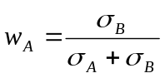 in A and the rest in B.
Answer:

Thus,

The variance of the portfolio is given by:

This portfolio has zero variance; hence, it is riskless. This confirms what we learned in class—when two securities are perfectly negatively correlated, it is possible to form a zero-risk portfolio by combining them.

Chapter 5

3. The following diagram shows the investment opportunity set for portfolios containing stocks A and B. You need to know that:
- Point A on the graph represents a portfolio with 100% in stock A
- Point B represents a portfolio with 100% in stock B

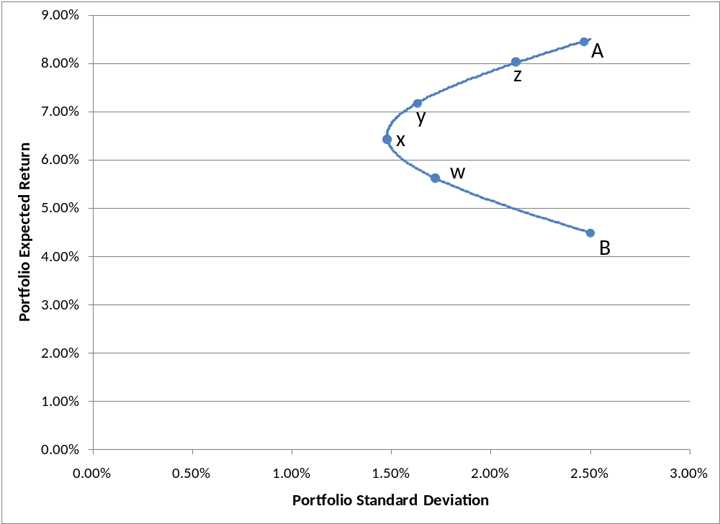

- Is the correlation between A and B greater than, equal to, or less than 1. How do you know?
- Which labeled point on the graph represents the minimum variance portfolio?
- Which labeled point on the graph represents a portfolio with 88% invested in stock A and the rest in B?
- If A and B are the only investments available to an investor, which of the labeled portfolios are efficient?
- Suppose a risk-free asset exists, allowing an investor to invest or borrow at the risk-free rate of 3%. If the above graph is drawn perfectly to scale, which labeled point represents the optimal risky portfolio.
- Under the assumptions in part (e), would it be wise for an investor to invest all of his or her money in stock A? Why or why not?

Answer:

- Less than 1. Correlation can’t be greater than 1, and if correlation equaled 1 (meaning that A and B were perfectly positively correlated), then the IOS between A and B would be a straight line.

- x

- z. This should be obvious, since a portfolio with 88% in A will be much closer to A than B on the curve. You can also confirm mathematically by noting from the graph that E(r_{A}) ≈ 8.5% and E(r_{B}) ≈ 4.5%. Thus, a portfolio with 87% in A will have E(r_{P}) ≈ 0.88(.085) + 0.12(.045) = 0.0802, which is approximately the expected return of portfolio z in the graph.
- x, y, z, and A

- y. Note on the graph that the tangency line from the risk-free asset intercepts the IOS at y.

- No. When the investor has the ability to borrow or lend at the risk-free rate, only the portfolios on the tangency line are efficient. Note in the graph above that by borrowing at the risk-free rate and investing everything in the optimal risky portfolio (y, in this case), the investor can create portfolios that that dominate A.
Chapter: 5 and 6

Essay

1. Describe what is semivariance? Give reasons why semivariance is not used as a measure of dispersion.
Answer:
Semivariance is a measure of dispersion that considers only the deviations of the returns which are below the average desired returns. This may be useful as the only returns that alarm an investor are the returns that are below the desired level.

For a well-diversified equity portfolio, symmetrical distribution is a reasonable assumption and hence, variance is also an appropriate measure of downside risk.

Furthermore, since empirical evidence shows that most of the assets existing in the market have returns that are reasonably symmetrical, semivariance is not needed because if returns on an asset are symmetrical; the semivariance is proportional to the variance. Thus, in most of the cases, not the semivariance, but the variance, is used as a measure of dispersion.
Chapter: 4

2. Under what condition will adding a security with a high standard deviation decrease the risk of a portfolio?
Answer:
The risk of a combination of assets is different from a simple average of the risk of individual assets. The standard deviation of a combination of two assets may be less than the variance of either of the assets themselves.

Adding a security with a high standard deviation to a portfolio can reduce the overall risk of portfolio if the security is negatively correlated to the bulk of securities in the portfolio. In a condition where two securities are perfectly negatively correlated, the securities will move together but in opposite directions. The standard deviation of such a portfolio will be smaller than a portfolio whose securities are positively correlated. If two securities are perfectly negatively correlated, it should always be possible to find some combination of these two securities that has zero risk. A zero risk portfolio will always involve positive investment in both the securities.
Chapter: 5

3. With the help of a diagram show, how would you identify a ray with the greatest slope as an efficient frontier where riskless lending and borrowing is present?
Answer:
We understand that the existence of riskless lending and borrowing implies that there is a single portfolio of risky assets that is preferred to all other portfolios. In the return standard deviation space, this portfolio plots on the ray connecting the riskless asset and the risky portfolio that lies farthest in the counter clockwise direction. We can judge from the below given graph that the ray 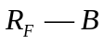 is preferred by the investors to any other portfolio or rays like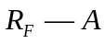. The efficient frontier is the entire length of the ray extending through 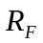and.

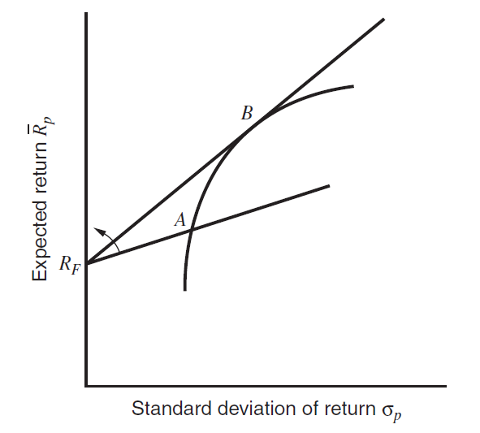

The slope of the line connecting a riskless asset and a risky portfolio is the expected return on the portfolio minus the risk-free rate divided by the standard deviation of the return on the portfolio. Thus, the efficient set is determined by finding a portfolio with the greatest ratio of excess return to standard deviation that satisfies the constraint that the sum of the proportions invested in the assets equals 1.
Chapter: 6

PART 2 – Section 2: Simplifying the Portfolio Selection Process

Multiple Choice

1. If the returns on different assets are uncorrelated:
a. an increase in the number of assets in a portfolio may bring the standard deviation of the portfolio close to zero.
b. there will be little gain from diversification.
c. diversification will result in risk averaging but not in risk reduction.
d. the expected return on a portfolio of such assets should be zero.
Answer: A
Chapter: 4

2. Using the Sharpe single-index model with a random portfolio of U.S. common stocks, as one increases the number of stocks in the portfolio, the total risk of the portfolio will:
a. approach zero.
b. approach the portfolio's systematic risk.
c. approach the portfolio's non-systematic risk.
d. not be affected.
Answer: B
Chapter: 7

3. What is the concept behind the indexes used in the Fama and French Model?
a. Form portfolios with standard deviations that mimic the impact of the variables.
b. Form portfolios with returns that are opposite to the impact of the variables.
c. Form portfolios with returns that mimic the impact of the variables.
d. Form portfolios with standard deviations that are opposite to the impact of the variables.
Answer: C
Chapter: 8

4. Which of the following is true of a cutoff rate?
a. The cutoff rate is be determined by dividing the Beta with the difference between average return and return on the riskfree rate of the securities.
b. All securities whose return is above the cutoff rate are selected in the market portfolio.
c. The cutoff rate is computed from the characteristics of all securities in the optimum portfolio.
d. All securities whose risk is below the cutoff rate are selected in the optimum portfolio.
Answer: C
Chapter: 9

True-False With Discussion

1. Discuss whether the following statement is true or false:
One can always construct a multi-index model that explains more of the returns on a security than a single-index model does.
Answer: True
The single-index model assumes that the stock prices move together only because of common movement in the market. Hence, the single index-model derives returns on securities with the help of the market movement in which the securities are being traded. Although, according to many researchers, there are influences beyond the market that cause stocks to move together. The multi-index model includes two different types of schemes that have been put forth for handling additional influences. Hence, the multi-index model takes into consideration the return on securities by introducing additional sources of covariance. By adding these additional influences, the multi-index model explains more of the returns to the general return equation of the single-index model.
Chapter: 8

2. Discuss whether the following statement is true or false:
A multi-index model will predict returns better than a single-index model.
Answer: False
The multi-index model lies in an intermediate position between the full historical correlation matrix and the single-index model in its ability to reproduce the historical correlation matrix. Adding more indexes complicates things but result in a more accurate representation of the historical correlation matrix. However, this does not imply that future correlation matrices will be forecast more accurately.
Chapter: 8

Problems

1. Consider the following data for assets A and B:
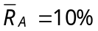; 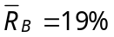; 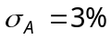; 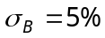; 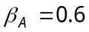; 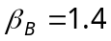; 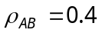.

a. Calculate the expected return, variance, and beta of a portfolio constructed by investing 1/3 of your funds in asset A and 2/3 in asset B.
b. If only the riskless asset and assets A and B are available, find the optimum risky-asset portfolio if the risk-free rate is 8%.
Answer: a. Expected return on a portfolio =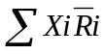.
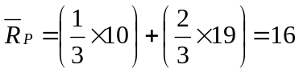.
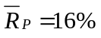

To construct the portfolio with investments A and B, the variance of the portfolios will have to be calculated as:
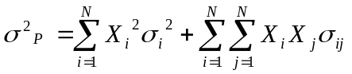
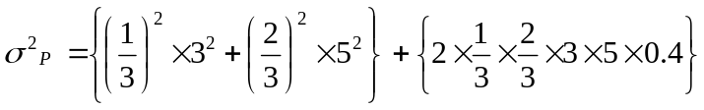
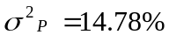.

The Beta of a portfolio can be calculated by the following method:
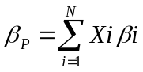
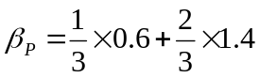
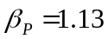

b. Calculating for market variance we get,

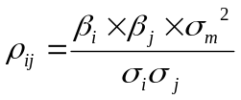
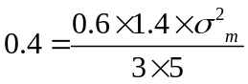
Hence,
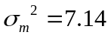

Now,
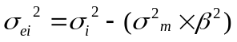

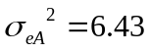
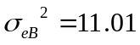

Security | Mean Return | Excess Return | Beta | Excess Return Over Beta | 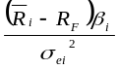 | 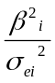 | 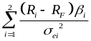 | 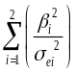 | 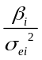
B | 19 | 11 | 1.4 | 7.86 | 1.399 | 0.178 | 1.399 | 0.178 | 0.127
A | 10 | 2 | 0.6 | 3.33 | 0.1866 | 0.033 | 1.586 | 0.211 | 0.093

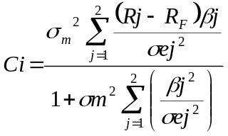
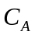= 4.520
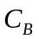= 4.398 (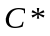)
(As is lower than the excess return over risk, we consider as the cutoff rate)
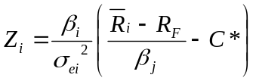

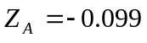
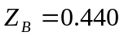

Therefore, the optimum portfolio will have its proportion of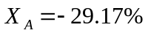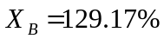.
Chapter: 7 and 9

2. Consider the following data for assets A, B, and C
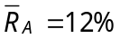; 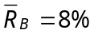; 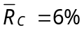; 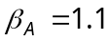; 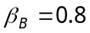; 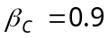; 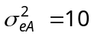; 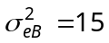; 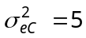.

Assume the variance of the market portfolio is 20 and that a riskless asset exists. Set up the first-order conditions for the optimum risky-asset portfolio.
Answer:
Assuming a risk free rate of 5%, we get the following values for the optimum portfolio:
Security | Mean Return | Excess Return | Beta | Excess Return over Beta | 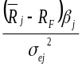 | 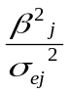 | 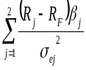 | 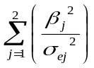 | 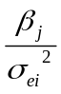
A | 12 | 7 | 1.1 | 6.36 | 0.77 | 0.121 | 0.77 | 0.121 | 0.11
B | 8 | 3 | 0.8 | 3.75 | 0.16 | 0.043 | 0.93 | 0.164 | 0.053
C | 6 | 1 | 0.9 | 1.11 | 0.18 | 0.162 | 1.11 | 0.326 | 0.18

The cutoff rate 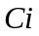of for an optimum portfolio can be found by the following equation:

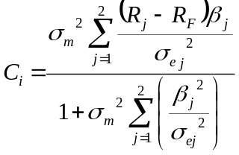

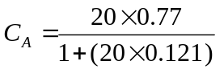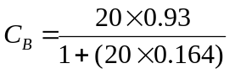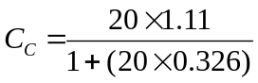

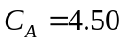(C*);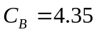;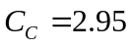
The ratio of excess return over Beta is higher than the cutoff rate of 4.50 for only security A. Hence, we conclude that only security A is included in the first order equation of the optimal risky portfolio.
Chapter: 9

3. Consider the following historical data for the returns on assets A and B and the market portfolio:

Period Asset A Asset B Market Portfolio
1 10% 6% 4%
2 3% 6% 1%
3 5% 2% 5%
4 2% 4% 2%
5 1% 2% 1%

a. What is the covariance between asset A and asset B?
b. If the beta of asset B is 0.5, what is the systematic return and non-systematic return for asset B in each period?
Answer: a.
Period | Asset A | Asset B | Asset A− Average A  (1) | Asset B −Average B  (2) | (1×2)
1 | 10 | 6 | 7 | 2 | 14
2 | −3 | 6 | −6 | 2 | −12
3 | 5 | 2 | 2 | −2 | −4
4 | 2 | 4 | −1 | 0 | 0
5 | 1 | 2 | −2 | −2 | 4
Total | 15 | 20 |  |  | 2
Average | 3 | 4

Hence, the Covariance (A, B) = 2 ÷ 5 = 0.4

b. From the given information, we know that the average return on asset B is 4%, average return on market is 2.6% and the Beta of asset B is 0.5. Based on this information, we can find the value of systematic return (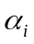) and unsystematic return ().

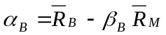 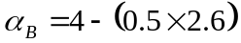 Hence, 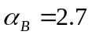

To find the value of the unsystematic risk for all periods, we used the following formula:
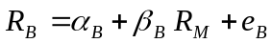
Period | 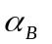 | 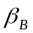 | 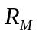 | 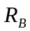 | 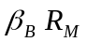 | 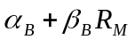 | 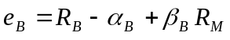
1 | 2.7 | 0.5 | 4 | 6 | 2 | 4.7 | 1.3
2 | 2.7 | 0.5 | 1 | 6 | 0.5 | 3.2 | 2.8
3 | 2.7 | 0.5 | 5 | 2 | 2.5 | 5.2 | −3.2
4 | 2.7 | 0.5 | 2 | 4 | 1.0 | 3.7 | 0.3
5 | 2.7 | 0.5 | 1 | 2 | 0.5 | 3.2 | −1.2

Hence, the systematic return will remain 2.7% for all periods. The unsystematic return will be 1.3% for period 1, 2.8% for period 2, −3.2% for period 3, 0.3% for period 4 and −1.2% for period 5.
Chapter: 7

4. The annual returns of Wonder Widgets, Inc. and the S&P 500 Composite Index over the last ten years were as follows:

Year Wonder Widgets S&P 500
1 −15% −8.5%
2 10% 4.0%
3 12% 14.0%
4 20% 15.0%
5 −20% −14.0%
6 −15% −26.0%
7 25% 37.0%
8 30% 24.0%
9 −10% −7.0%
10 3% 6.5%

Find the following for Wonder Widgets:
a. Beta (β_{W}, slope of regression line)
b. Alpha (α_{W}, intercept of regression line)
c. Unsystematic variance (σ²_{W} − β²_{W}σ²_{m})
d. Correlation coefficient (ρ)
Answer:
Year | 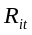 | 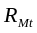 | 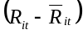 | 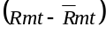 | 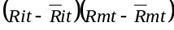 | 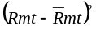 | 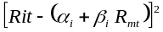 | 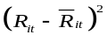
1 | −15 | −8.5 | −19 | −13 | 247 | 169 | 55.29 | 361
2 | 10 | 4 | 6 | −0.5 | −3 | 0.25 | 41.54 | 36
3 | 12 | 14 | 8 | 9.5 | 76 | 90.25 | 0.21 | 64
4 | 20 | 15 | 16 | 10.5 | 168 | 110.25 | 44.26 | 256
5 | −20 | −14 | −24 | −18.5 | 444 | 342.25 | 56.80 | 576
6 | −15 | −26 | −19 | −30.5 | 579.5 | 930.25 | 66.31 | 361
7 | 25 | 37 | 21 | 32.5 | 682.5 | 1056.25 | 62.84 | 441
8 | 30 | 24 | 26 | 19.5 | 507 | 380.25 | 74.70 | 676
9 | −10 | −7 | −14 | −11.5 | 161 | 132.25 | 14.19 | 196
10 | 3 | 6.5 | −1 | 2 | −2 | 4 | 7.74 | 1
Total | 40 | 45 |  |  | 2860 | 3215 | 423.88 | 2968
Mean | 4 | 4.5 |  |  |  | 321.5 |  | 296.8

a. Beta: 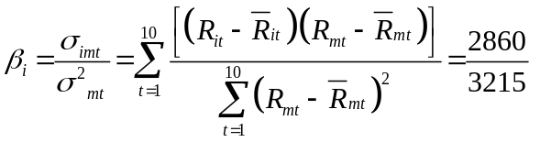= 0.89

b. Alpha: 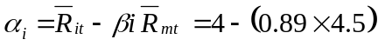= −0.0031

c. Unsystematic Variance: 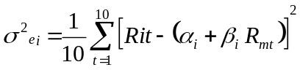
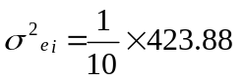= 42.388

d. Correlation Coefficient: 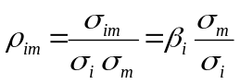

= 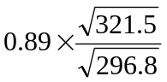
= 0.93
Chapter: 7

5. You are the pension fund manager for a major university with $100 million in an index fund that invests in the S&P 500 stocks. (The fund holds all the stocks in the index in proportion to their market values.) Due to recent pressure from student groups, the regents have decided to divest themselves of the stocks of firms that invest in South Africa. You estimate that this will eliminate 100 of the 500 stocks in your portfolio. You have been asked to evaluate the effect of the divestiture decision. You estimate that the correlation between acceptable and eliminated stocks is 0.6. You also have the following data:

Acceptable Stocks Eliminated Stocks
Number of Firms 400 100
Total Market Value $3 billion $2 billion
Average Beta 1.0 1.25
Standard Deviation 25% 30%

a. What will the effect of the divestment be on the beta of your portfolio? (Report the beta before and after the divestment.)
b. How will divestment affect the standard deviation of your portfolio? (Report the standard deviation before and after the divestment.)
c. Assume that the standard deviation of the overall market is 20%. What is the effect of divestment on the proportion of your portfolio's risk that is unsystematic? (Report the proportion before and after the divestment.)
Answer:
a. 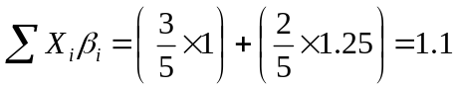(Before divestment)
After divestment, the Beta is given as 1.
b. 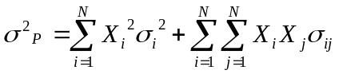
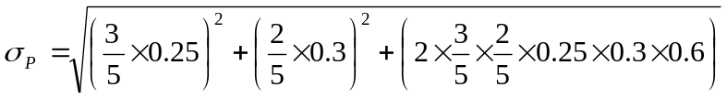= 24.19% (Before divestment).
After divestment, the standard deviation is given as 25%

c. If the standard deviation of the overall market is 20%, and the standard deviation of the portfolio before divestment was 24.19%.

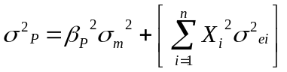
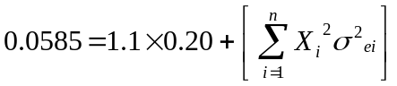
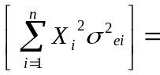1.01% (unsystematic risk before elimination)

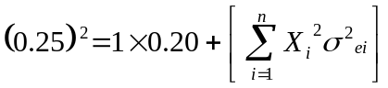
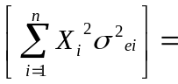2.25% (unsystematic risk after elimination)
Chapter: 7

6. A security analyst works for a large institution that uses the single-index model as part of its portfolio-management scheme. The security analyst believes the following values are relevant for the four stocks she follows
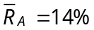; 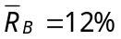; 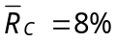; 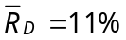; 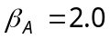; 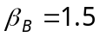; 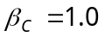; 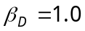; 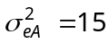; 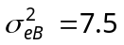; 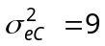; 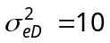.

The institution assumes that the risk-free rate is 6%, and short selling is not allowed. The institution accepts the Sharpe single-index model and uses the procedure described by Elton, Gruber and Padberg (EGP) to determine the optimum risky-asset portfolio for the institution to hold. The procedure is to compute

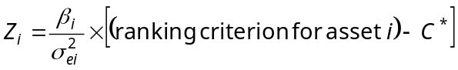

where the ranking criterion is as described by EGP and where C* depends on all risky assets the institution holds. The institution's management has determined that C* = 3.

a. Which stocks that the analyst follows will be held in the institution's optimum portfolio?
b. If the sum of the Z_{i}'s for all the institution's stocks in the optimum portfolio is equal to 4, what fraction of the institution's optimum portfolio will each of the stocks that the analyst follows represent?
c. Why should 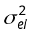 (diversifiable risk) enter into the optimal solution?
Answer:
Security | Mean Return | Excess Return (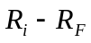) | Beta | Excess Return over Beta | 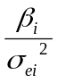
A | 14 | 8 | 2 | 4 | 0.1333
B | 12 | 6 | 1.5 | 4 | 0.2000
C | 8 | 2 | 1 | 2 | 0.1111
D | 11 | 5 | 1 | 5 | 0.1000

a. if 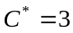, the stocks A, B, and D can be held in the optimum portfolio, as their excess return over Beta is higher than the cutoff rate.

b. If the sum of 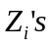 for all the institution’s stocks in the optimum portfolio equals 4, the fraction of the institution’s optimum portfolio will be represent as Z_{A}/4, Z_{B}/4, and Z_{D}/4.

Hence, in this case, the fraction of the institution’s optimum portfolio can be found by using the following equation:

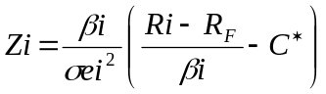
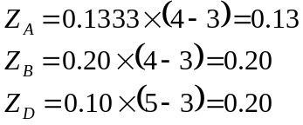
Therefore, the fraction of the portfolio is Z_{A} =0.13/4, Z_{B} = 0.20/4, and Z_{D} = 0.20/4. Therefore, Stock A has a proportion of 3%, Stock B has a 5% proportion and Stock D has a proportion of 5%.

c. 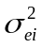 is denoted as the variance of a stock’s movement that is not associated with the movement of market index. The residual variance plays an important role in determining how much to invest in each security.
Chapter: 9

Essays

1. What is a stock's own variance and what is the covariance between two stocks if one accepts the Sharpe single-index model? Explain why each is what it is.
Answer:
In a single-index model for expected return, a security’s variance has two parts, unique risk and market-related risk. The covariance depends only on the market risk. That is why the single-index model implies that the only reason securities move together is a common response to market movements.
The model’s basic equation is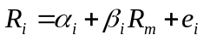. Where, 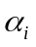denotes the expected value of the component of return insensitive to the return on the market, represents the random element of the component, and  is the constant Beta used to measure the expected change in return on the security in comparison to the return on markets. The variance of return on any security is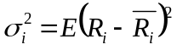. From this we understand that the variance of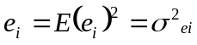. The covariance between any two securities is described as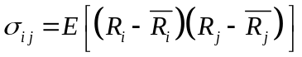. After substituting the returns and average returns of the securities with the single-index model, we get the stock’s variance and the covariance between two stocks. We can hence find that the variance of a security’s return is 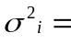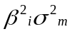+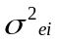 and the covariance of two securities is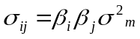.
Chapter: 7

2. Discuss how betas are obtained and some of the innovations that have been used to predict their values.
Answer:
Security returns are correlated because of a common response to market changes, and a useful measure of this correlation might be obtained by relating the return on a stock to the return on a stock market index. The Beta of a security measures how sensitive a stock’s return is to the return on the market.
A Beta of 2 denotes that a stock’s return is expected to increase (decrease) by 2%, when the market increases (decreases) by 1%. Similarly, a Beta of 0.5 indicates that a stock’s return is expected to increase (decrease) by 1/2 of 1% when the market increases (decreases) by 1%.

The Beta of a security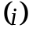divides the return of a security into market-related and unique return. When Beta is set equal to 1.5 for example, the market return is independent of the residual return,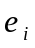. A lower value of leaves some market return in, and the covariance of with the market will turn out to be positive. A Beta greater than 1.5 removes too much market return and results in a negative covariance between and the market. Thus, the value of Beta is unique and it is the value that exactly separates market from unique return, making the covariance between market return and residual return zero.

The use of single-index model requires estimates of Beta for each stock that is to be included in a portfolio. The Beta can be derived by subjective estimates of a Beta of a security or a portfolio. Estimates of future Beta can also be arrived at by estimating Beta from the past data. Some of the techniques used by analysts for estimating Beta are, measuring historical Betas, correcting historical Betas as the tendency of historical Betas is to be closer to the mean when estimated in a future period, and correcting historical estimates by incorporating fundamental firm data.

The Beta of a firm that can be typically estimated by using the regression analysis, is
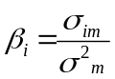. This formula means the covariance of the stock with the market divided by the variance of the market.
Chapter: 7

3. How would you decide whether the constant-correlation model or the Sharpe single-index model was superior?
Answer:
More complex models become more confusing as they include more noise than information. More and more, industry and the academic professionals have come to realize how difficult it is to estimate, based on judgment, the correlation among stocks.
Recent literature has compared and tested several techniques assuming the correlation constant within and among groups and examined methods for combining estimates from different techniques into better estimates.

In the single-index model, a security’s variance is taken into consideration and consists of two parts, unique risk and market related risk. The covariance depends on the market risk. The single-index model is accepted as the best way to forecast the covariance structure of returns.

Whereas, the constant-correlation model assumes that the correlation between all pairs of securities is the same. If the constant correlation model is accepted as describing the co-movement between securities, then all securities can be ranked by their excess return to standard deviation.

The research has proved that simple is better than complex. The constant correlations model works best followed by the Sharpe single-index model as forecasters of future correlation.
Chapter: 8 and 9

4. How is the ranking of a multi-group model determined? How is it different from the index models?
Answer:
If a multi-group model is employed, then the ranking of a portfolio is always in terms of excess return to standard deviation because the cutoff rate varies from one group to the other. The cutoff rate of multi-group models depends on the basis of which securities are to be included and in which group.

In single-index and multi-index models, the ranking is done by excess return to Beta. Beta is important in index models because it is a measure of the securities’ contribution to the risk of the portfolio.
However, in multi-group models, the contribution to portfolio risk depends on the standard deviation and, hence, standard deviation is the risk measure in the portfolios.
Chapter: 9

5. Discuss the portfolio formation process using size and book-to-market ratio in the Fama-French Multi Index Model
Answer:
Size is defined as the total market value of equity (price times number of shares outstanding). Two groups are constructed using size. The first group contains all stocks on the NYSE, AMEX, and NASDAQ that have a size large than the median size of a NYSE stock and the second group contains all the smaller stocks. In case of book-to-market (ratio of book value of equity to market value of equity), three groups are formed. The break points are defined by the break points of the lowest 30% (S), middle 40% (M), and highest 30% (H) of stocks in the NYSE.

This two way classification is then used to form five portfolios, with the first one containing all stocks that fall in the small size and low book-to-market category, and the fifth one containing the largest stock with the highest book-to-market values.
Chapter: 8

PART 2 – Section 3: Selecting the Optimum Portfolio

Multiple Choice

1. Under the assumption that the future stream of interest rates is perpetual and fixed, dividend ratio predicts a low future equity premium, when:
a. stocks are equally prices compared to their future dividends.
b. stocks have high prices compared to their future dividends.
c. stocks have low prices compared to their current dividends.
d. stocks have high prices compared to their current dividends.
Answer: D
Chapter: 10

2. The Value at Risk approach:
a. chooses the valuable large outcome over small in a portfolio .
b. determines the highest expected value of terminal wealth in a portfolio.
c. only looks at the likelihood of bad outcomes.
d. involves a trade-off of expected return and a bad outcome in a portfolio.
Answer: C
Chapter: 11

3. Market based forward looking estimate of future expected returns are obtained using one of the following:
a. Estimation of the market probabilities from the prices at which derivative securities trade.
b. Historical data to estimate expected returns and measures of risk
c. Estimation of equity risk premium
d. Earning-price ratio and dividend-price ratio.
Answer: A
Chapter: 10

Essays

- Explain how the equity premium work in estimating expected returns.
Answer:
Equity premium is the amount of return that an investor demands for holding risky securities as opposed to the riskless securities.
Since securities are priced based on their relative risk, it is believed that if one can estimate one asset category with relative accuracy, pricing other assets relative to that category is an efficient way to forecast expected returns.

The expected riskfree return, like the one-year Treasury bill return, is a quantity that can be observed in the market. Thus the treasury bills or the riskfree returns are a useful way to benchmark for building expected returns for other categories.

The equity premium is added to the current riskfree security rate to form a forward-looking expected return for the equity portfolio. This same principle can be applied to all other asset classes as well.
Chapter: 10

2. Discuss the differences between absolute and relative risk aversion.
Answer:
A tradeoff between risk and return is known as the coefficient of risk aversion.
Assume that the wealth of an investor increases. Now, if the investor does not change the percentage of investment in risky assets from before, the investor is exhibiting constant relative risk aversion. If the investor increases the percentage of investment in risky assets, the investor exhibits decreasing relative risk aversion. On the contrary, if the percentage of investment in risky assets reduces, the investor is said to be exhibiting increasing relative risk aversion.

Absolute risk aversion refers to an investor who only chooses to invest in less risky securities.
The return on an absolute risk aversion portfolio is always lower than that of a relative risk aversion portfolio.

In equilibrium of demand and supply for assets, which is dominated by very risk-averse investors, the risky assets will play a role of stocks that provide a higher expected return in order to attract extra cautious investors. Although, in equilibrium, where there are a lot of relatively risk averse investors, the spread in expected return between risky and non risky assets will be small, bringing in a discrepancy between investors who are absolutely risk averse, and relatively risk averse.
Chapter: 11

3. Discuss the economic properties of utility functions.
Answer:
The first economic property talks about an investor choosing between investments having possible outcomes, and specifying how much more valuable the large outcomes are, relative to the small outcomes. And after doing that, the investor weights the outcomes by their value and finds the expected values of those outcomes. The weighting function of the outcomes is called the utility function. If utility increases as weight increases, then the first derivative of utility, with respect to wealth, is positive. Any investor can choose between alternatives by maximizing expected utility. This means that a utility of more (X+ 1) dollars is always higher than the utility of less (X) dollars.
The second property of the utility functions is an assumption about an investor’s choice for risk: an investor can be averse to risk, neutral, or seek for more risk. These three can be defined as an investor’s level of fair gamble. The risk averse investor would reject a fair gamble, a risk neutral would be indifferent, and a risk seeker would select a fair gamble.

The third economic property of utility function is an assumption about the change in an investor’s preference with a change in the wealth. Investors may be willing to take on more risk exhibiting decreasing relative risk aversion. On the other hand, increasing relative risk aversion is when the investor invests a smaller percentage in risky assets. When the investor chooses to invest the same percentage of wealth in risky assets as before, he or she is said to be exhibiting constant relative risk aversion.
Chapter: 11

4. Compare the similarities and differences of Roy’s “safety-first” criterion and Kataoka’s “safety-first” criterion.
Answer:
The safety-first model is a simple decision model which only concentrates on bad outcomes and placing criteria for limiting the risk of bad outcomes.
The safety criteria developed by Roy states that the best portfolio is the one that has the least possibility to turn out returns lower than a set criteria. Whereas, the safety-first criteria developed by Kataoka suggests to maximize the lower limit, subject to the constraint that the probability of a return less than, or equal to, the lower limit is not greater than some predetermined value.

If 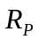 is the return on the portfolio and 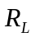 is the level below which the investor does not wish returns to fall, Roy’s criterion says minimize probability of falling below: minimize Probability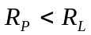. Whereas, according to Kataoka, if is the probability of a return below the lower limit, the investor will have to maximize R_{L}, subject to Probability 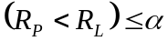

Under both Roy's and Kataoka's criterion, the optimum portfolio must be on the efficient frontier curve in mean standard deviation space.
Chapter: 11

PART 2 – Section 4: Widening the Selection Universe

Multiple Choice

1. As the exchange risk and the within country risk are usually relatively independent:
a. an investor in the U.S. faces a higher exchange risk than the sum of exchange risk and within country risk.
b. an investor in the U.S. faces the same exchange risk as the sum of exchange risk and within country risk.
c. a U.S. investor’s exchange risk is unaffected by any change in the sum of exchange risk and within country risk.
d. an investor in the U.S. faces a lower total risk than the sum of exchange risk and within country risk.
Answer: D
Chapter: 12

Essays

1. Discuss the effect of exchange-rate risk on international investments. Does it matter from which viewpoint (foreign vs. domestic) that risk and return are calculated?
Answer:
The exchange risk arises because the exchange rate between two currencies changes over time. The viewpoint from which risk and return of these currencies are calculated does matter. If we take an example of the returns to a U.S. investor on an investment in Japanese securities, the variability of exchange rates will be derived by examining the variability of the Japanese currency in dollars, implying that the total risk is measured from a U.S. investor’s point of view.

Assuming a situation in which the standard deviation of domestic markets is lower than the standard deviation of other market indexes. Taking into account the effect of exchange risk in such a situation makes the higher risk of foreign markets even more evident. For example, when returns on long term U.S. bonds are adjusted for changes in exchange rates and all returns of other indexes are expressed in dollars; the risk of the U.S. bond index is much lower than for any foreign index. Hence, it becomes important for risk and return to be calculated for the exchange rate fluctuations.
Chapter: 12

